**Programming IOT**

**Smart Parking System**

By:

Sudhanshu Modi

1. **Introduction:**

With the advent of connected devices, IoT-based smart parking systems are growing in popularity. These parking systems provide drivers with advanced information about available parking spaces and other useful data such as current prices and vacancy rates.

Intelligent parking systems also allow drivers to use parking spaces remotely via smartphone. This is useful if drivers don't want to walk to find a parking space or want to avoid potential traffic jams.

An IoT-based smart parking system, also known as a connected parking system, is a centralized management system that allows drivers to search and reserve parking spaces using a smartphone app.

The system's hardware has sensors that detect available parking spaces and relay this information to all drivers in the area. This data is updated in real time, so drivers don't have to worry about not finding free space.

The system not only helps drivers find seats, but also sends alerts about peak hours and peak prices. The purpose of these alerts is to help drivers save money while reducing congestion.

* **Why Smart parking lots are needed?**

Demand for parking spaces is ever increasing, and as cars become more fuel efficient, the number of vehicles will continue to grow. As a result, there are fewer parking spaces.

Intelligent parking systems provide drivers with information about available spaces in the area to solve the problem of finding a free parking space. Drivers can also use the system remotely via their smartphone to find a space before they even reach the parking lot.

These systems allow drivers to find available spaces faster and easier than traditional methods of driving or waiting for someone to leave. Using this technology saves drivers time searching for a parking space.

* **How does it work?**

Parking system is installed outside the building or inside the building. When a vehicle enters an empty space, sensors detect its presence and calculate available parking spaces. This information is then sent to the driver's phone via an app.

The smart parking system also has real-time data on occupancy rates, which can be found on the app. This data is collected from each sensor and updated every 5 minutes. A major drawback of the automated parking system is that it has increased competition for parking in urban areas with limited space nearby. However, even if these systems are useful to drivers, this type of initiative has certain drawbacks.

Drivers who depend on public transport may not have the option to use the app as they do not own a car or drive their own vehicle. These systems are also highly maintainable as many sensors need to be replaced frequently due to wear or vandalism.

**What problems will you have when parking your car?**

* The parking lot is saturated - The most serious problem is the increasing number of cars without increasing the parking space leading to traffic jams.
* Overpaying - Sometimes drivers or customers don't know how long they will stay in a particular location. So they sometimes pay too high a parking fee.
* Impact on the environment - The parking lot accumulates an unabsorbable amount of dirt and is released into the water environment when it rains. On-street or off-street parking - There is not enough space in the parking lot of shopping malls or reservation areas, in this case, heavy traffic jam will appear.
* Improper use of existing parking lot - People are always in a rush and desire to park properly which leads to insufficient parking space for other vehicles.

1. **Literature Review & research gap:**

The ideal of creating a Smart City is now becoming possible with the advent of the Internet of Things. One of the main issues that smart cities deal with are parking facilities and traffic management systems. In today's cities, finding an available parking space is always difficult for drivers, and it tends to become more difficult with the increasing number of people using passenger cars. This situation can be seen as an opportunity for smart cities to take actions to improve the efficiency of parking resources, resulting in reduced search times, traffic congestion and road accidents. . Problems related to parking and traffic congestion could be solved if motorists could be informed in advance of the availability of parking at and around their intended destination. Recent advances in creating low-cost, low-power embedded systems are helping developers create new applications for the Internet of Things. Following the development of sensor technology, many modern cities have chosen to deploy various IoT-based systems in and around cities for monitoring purposes. A recent survey by the International Parking Institute reflects an increase in the number of innovative ideas related to parking systems. There are currently several parking systems that claim to provide residents with real-time information about available parking spaces. Such systems require the deployment of efficient sensors in parking areas to monitor usage as well as fast data processing units to derive useful insights from the collected data. collected from various sources.

* **Need of cloud integration:**

Cloud computing and IoT have undergone a tremendous evolution. Both technologies have their own advantages, but some common benefits can be expected from their integration. On the one hand, IoT can meet its technological limitations such as storage, processing, and power by exploiting the unlimited capabilities and resources of the Cloud. On the other hand, the cloud can also extend its reach to handle real-world entities in a more distributed and dynamic way through the use of IoT. Essentially, the cloud acts as a middleman between everything and the application, to hide all the complexity and functionality required for the application to work. Here are some factors that led to the fusion of Cloud and IoT.

* **Storage capacity:**

IoT consists of a large number of information sources (things), generating large amounts of unstructured or semi-structured data. Therefore, IoT requires the collection, access, processing, visualization, and sharing of large amounts of data. The cloud offers unlimited, inexpensive on-demand storage, making it the best and most cost-effective solution for handling IoT-generated data. Data stored in the Cloud is accessible and viewable from anywhere through standard APIs.

* **The ability to calculate:**

Devices used in IoT have limited processing capabilities. Data collected from different sensors is usually transmitted to more powerful nodes, where their aggregation and processing can be performed. IoT computing needs can be met using unlimited processing capacity and on-demand cloud model. With the help of cloud computing, IoT systems can perform real-time data processing thus facilitating highly responsive applications.

* **Ability of extension:**

The cloud provides a scalable approach to IoT. It allows to increase or decrease resources dynamically. Any number of "things" can be added to or subtracted from the system when cloud integration is provided. The cloud allocates resources based on the requirements of objects and applications.

* **Possibility:**

Anytime, anywhere, resource provisioning becomes super easy with cloud integration. Many cloud providers offer 5 nine availabilities. With the cloud, applications are always up and running and services are continuously delivered to end users.

* **Interactive ability:**

IoT involves the use of devices that are heterogeneous in nature. These devices may have different hardware or software configurations, leading to compatibility issues. It is difficult in an IoT environment to ensure interoperability between these devices [19]. The cloud helps to solve this problem because it provides a common platform on which different devices can connect and interact. Devices are allowed to share and exchange data in a format that suits them.

* **Possibility:**

Anytime, anywhere, resource provisioning becomes super easy with cloud integration. Many cloud providers offer 5 nine availability. With the cloud, applications are always up and running and services are continuously delivered to end users.

* **Sources of contact information:**

The basic function of IoT is for IP-enabled devices to communicate with each other through a set of specialized hardware. Cloud computing provides cheap and efficient ways to connect, monitor, and manage devices from anywhere on the Internet. Through the use of embedded applications, IoT systems can monitor and control things in real time through remote locations.

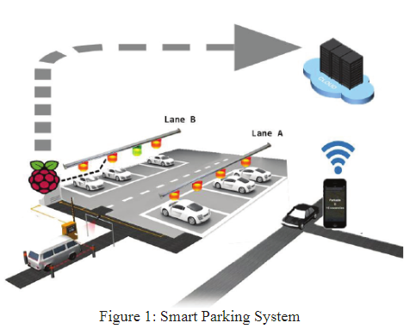

1. **Methodology:**

Equipment and devices:

* Arduino
* IR sensors
* 16x2 lcd
* Servo motor
* Jumper wires

**Smart parking system using IoT**

Ultrasonic, electromagnetic field detection and infrared are some of the types of smart parking sensors.

**Ultrasonic:**

The accuracy of smart parking sensors is improved through the use of ultrasonic waves. The downside of this type of sensor is that it can get dusty.

**Electromagnetic field detection:**

The sensor can detect small changes in the magnetic field when a metal object is nearby.

**Infrared:**

This type of sensor measures changes in ambient temperature and detects motion.

**How to install smart parking sensor using IoT?**

Different types of sensors are installed in different ways. For example, a camera is a fragile object, so it must be installed at a certain distance and at a certain angle to avoid blind spots. Laser radar sensors are usually installed in a column 30-80 cm away and placed several times in a certain range, but this only makes sense during large processing.

Underground vehicle IoT sensors are the easiest to install, usually installed on the floor of each parking lot to detect vehicles parked above. Such IoT sensors can be simply glued to a surface or fixed with screws. Furthermore, these IoT sensors are easy to switch with no unique installation practices and

most of them are maintenance-free. The smart parking system using IoT can communicate with the gate through the parking location and transmit the data to the Internet.

* **Three possible detection conditions**
* **Space occupied:**

The distance of the object detected by the sensors is between 10 and 50 cm (about 4 and 20 inches)

* **Space looks:**

Detected object distance is greater than 50 cm (approximately 20 inches)

* **Dirty space:**

The distance of the detected object is less than 10 cm (about 4 inches)

If the condition is "dirty", the sensors may be covered or blocked by something and should be checked.

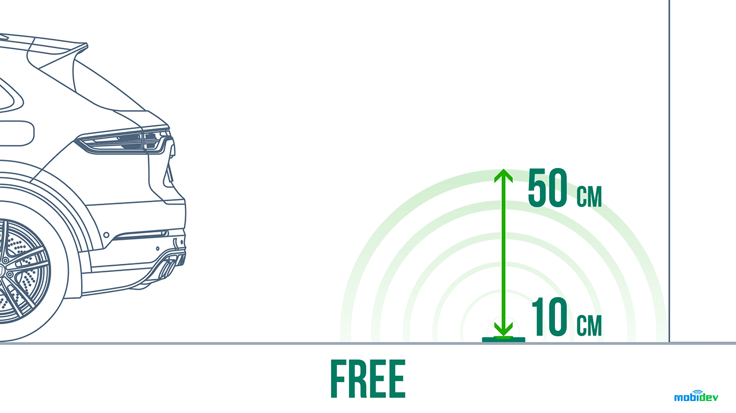

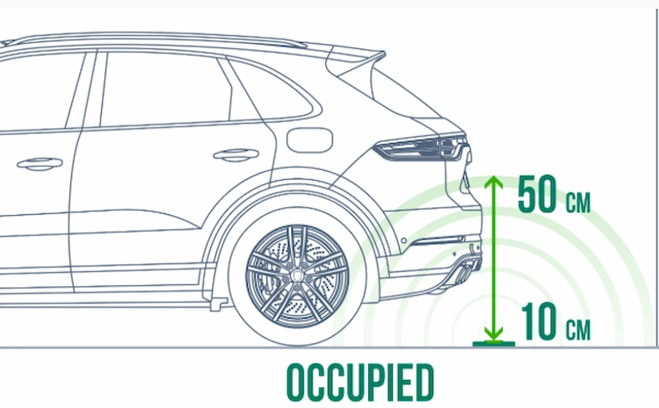

* **Working principle of smart parking sensor**

Vehicle presence detection in two steps. First, the IoT solution device needs to determine the presence of parked cars in a specific parking lot. Second, you need to make sure the parking lot is detected as occupied because there is only one vehicle. These two steps can be achieved through different engineering technology approaches, enabling smart parking systems using IoT to provide parking search, navigation and reservation.

Computer vision, proximity sensors, proximity sensors and even RF/magnetic presence can be used to build smart parking sensors. These technologies offer benefits such as highly accurate parking detection, wide-angle parking detection, energy savings, and simultaneous monitoring of multiple parking locations. Therefore, using a parking sensor mixed with remote communication is the best option. LoRa parking sensors provide the required extended range and reduce overall system costs due to the minimum number of gateway devices.

**Working of our Prototype:**

IR sensors are connected to the Arduino

A 16x2 lcd is also connected for display purpose.

When a vehicle comes at the entrance of the parking, the IR located there detects the vehicle and lifts the boom barrier which is connected to the servo motor.

**Working:**

We have connected 2 IR sensors, one is the front IR sensor, while the other one is the back IR sensor. The front IR sensor detects the incoming vehicles, while the back sensor detects the outgoing IR sensor. So, we have decided to make the miniature model of 5 spaces, we can easily make it more by editing in the code. When the vehicle is approaching the front IR sensor, the sensor detects it and sends the message to the Arduino board, which further sends the message to servo motor, which lifts the barrier and to LCD, which shows the total number of slots and the number of slots left. So as the vehicle enters the parking lot, the number of slots left will decrease (space=space-1), and when the vehicle is exiting the parking lot, the number of slots left will increase (space=space+1).

**Tinkercad Image:**

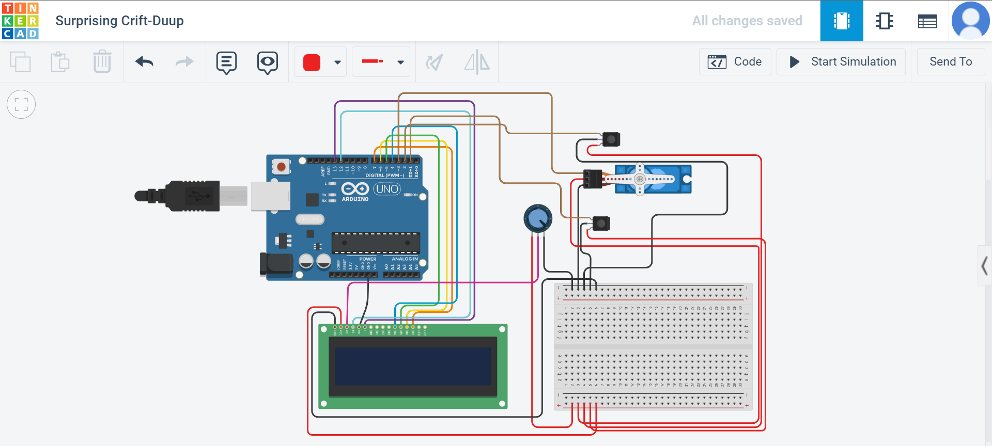

**Images of working model:**

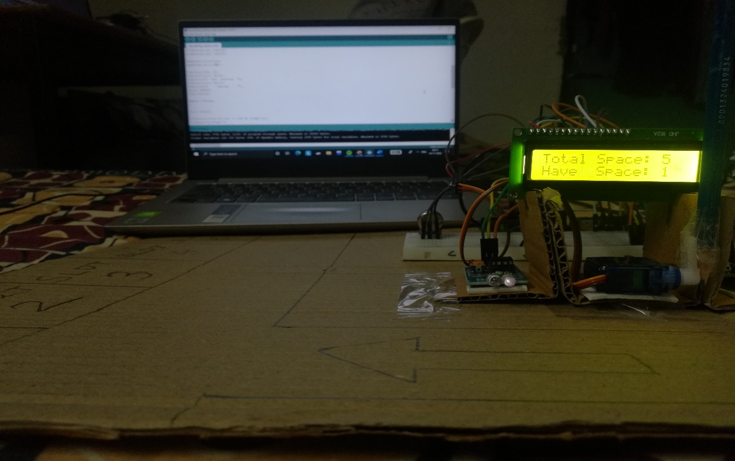

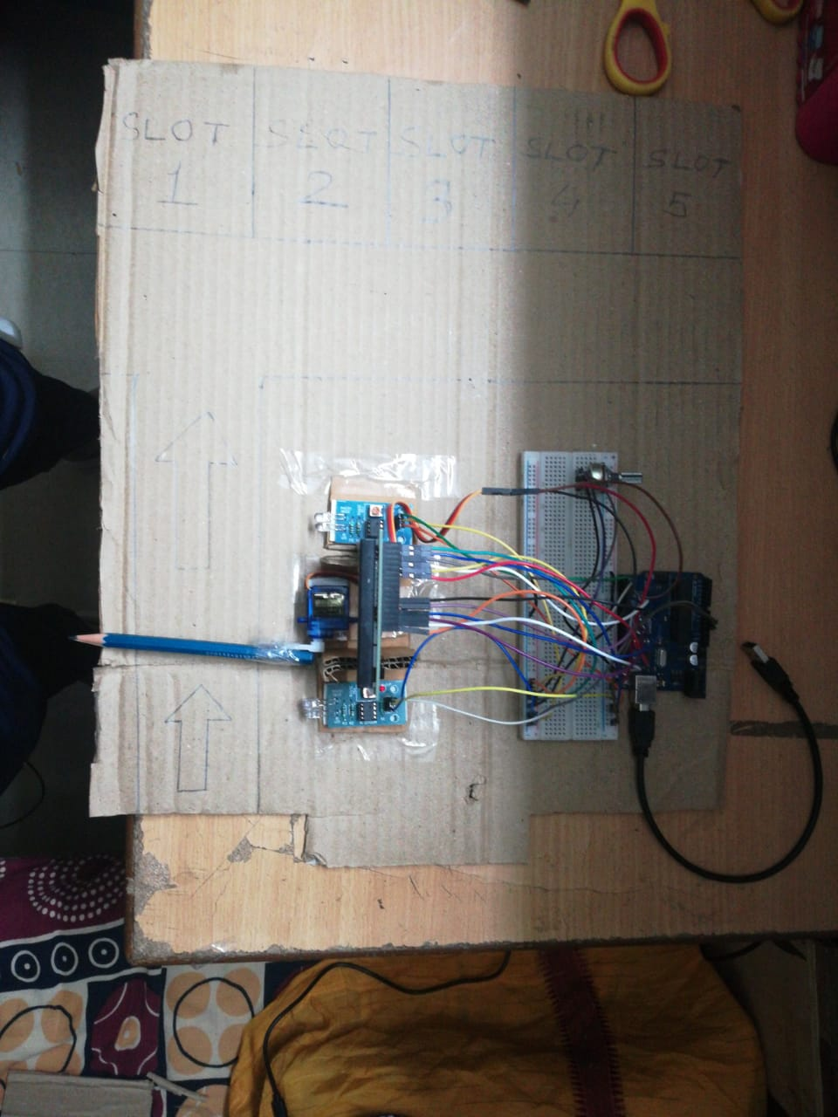

**Code:**

#include <LiquidCrystal.h>

LiquidCrystal lcd(12, 13, 4, 5, 6, 7);

#include <Servo.h>

Servo myservo1;

int ir_s1 = 2;

int ir_s2 = 1;

int Total = 5;

int Space;

int flag1 = 0;

int flag2 = 0;

void setup() {

pinMode(ir_s1, INPUT);

pinMode(ir_s2, INPUT);

myservo1.attach(3);

myservo1.write(90);

lcd.begin(16, 2);

lcd.setCursor (0,0);

lcd.print(" Car Parking ");

lcd.setCursor (0,1);

lcd.print(" System ");

delay (2000);

lcd.clear();

Space = Total;

}

void loop(){

if(digitalRead (ir_s1) == LOW && flag1==0){

if(Space>0){flag1=1;

if(flag2==0){myservo1.write(0); Space = Space-1;}

}else{

lcd.setCursor (0,0);

lcd.print(" Sorry not Space ");

lcd.setCursor (0,1);

lcd.print(" Available ");

delay (1000);

lcd.clear();

}

}

if(digitalRead (ir_s2) == LOW && flag2==0){flag2=1;

if(flag1==0){myservo1.write(0); Space = Space+1;}

}

if(flag1==1 && flag2==1){

delay (1000);

myservo1.write(100);

flag1=0, flag2=0;

}

lcd.setCursor (0,0);

lcd.print("Total Space: ");

lcd.print(Total);

lcd.setCursor (0,1);

lcd.print("Have Space: ");

lcd.print(Space);

}

1. **Result & discussions**

**Advantages of smart parking systems using IoT**

In an urban environment:

Direct benefits

* Optimizing parking space
* Special permits for loading and unloading, cabins, etc.
* Monitor parking spaces for the disabled
* Define areas for emergency vehicles
* Provide charging stations for electric vehicles

Indirect benefits:

* Reduce parking violations
* Reduce noise pollution
* Reduce emissions
* Increase parking revenue up to35%
* Improve reputation as a greener city/base
* Improve urban mobility and urban planning

Private space:

Shopping malls, hotels, amusement parks…

Direct benefits

* Optimizing parking space
* Special license:
* loading and unloading, cabins, etc.
* Parking monitoring for the disabled
* Charging station for electric vehicles
* Increase revenue

Indirect benefits:

* Dynamic pricing strategies based on occupancy
* Open usage for new customers:
* Parking space for carpooling vehicles.
* Improve customer experience
* Optimizing human resources to consumption habits
* **Smart parking system using IoT solution**

Smart parking solutions can reduce

* Traffic flow: -8%
* 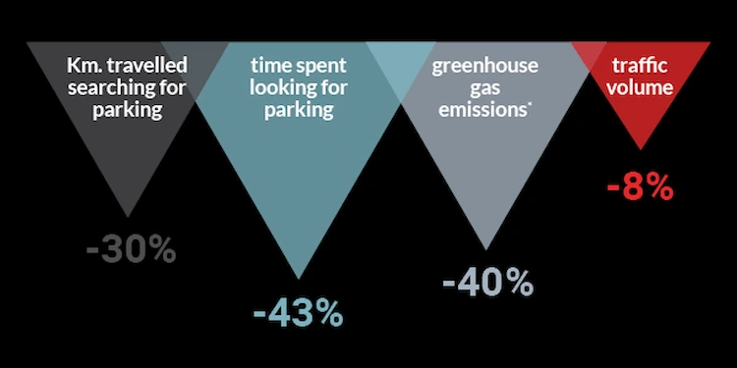Exhaust gas: -40%
* Travelled distance: -30%
* Time spent: -43%

Looking for a parking space

Spending 10 minutes looking for a car several times a day means you should spend 240 hours a year, and an average of 700 days in your entire life.

**Innovations in smart parking solutions**

According to the Smart Parking Institute survey, 42% of respondents voted in favor of the need for a parking system. The good news is that thanks to parking sensors, connectivity platforms and other IoT apps, drivers can find out the nearest parking spot if it's occupied. Real-time parking map will be popular in the future.

As for the innovations already in the field, here are the best smart parking apps that have been released or will be released soon.

**1. Vehicle tracking by sensor system**

Internet of Things is the core technology of vehicle tracking platform. Tools like GPS or OBD sensors can help collect location data of cars or fleets and monitor parking space usage. The information is transmitted to the CSA, processed, and then transmitted to the network server. This data will be presented to drivers and car company managers in an easy to understand and clear way.

Currently, IoT-based vehicle tracking devices are mainly used to manage large enterprise fleets. In the future, as the deployment of 5G makes the Internet of Things more accessible, parking technology will be ubiquitous among car drivers and used to manage daily journeys and alleviate parking problems car.

**2. Smart watch system**

The connected counting system detects the entry of cars in the parking lot. Thus, an IoT platform should be able to provide drivers with a real time counter of available gaps.

Facility managers can use the measurement system to improve the efficiency of parking lots, identify trends and traffic patterns, and can predict future vehicle growth.

**3. Automatic parking system**

Automated parking systems reduce the number of parking spaces and maximize space efficiency. An automated system is used to move vehicles up and down the upper floors of the facility. Since the APS facility is fully automated and has limited access, it is safer to park there.

The automatic parking system reduces search time and engine emissions that build up due to increased driving time. In such a facility, the use of resources is minimized as there is very little lighting and ventilation required to maintain the automated parking system.

* **The role of the Internet of Things in parking technology**

Smart parking will have a significant impact on all stakeholders throughout the process. Drivers can reserve parking spaces in advance, plan their routes and routes, and account for parking space usage. The enhanced mechanism will be able to detect and assess the severity of illegal parking in a split second.

Parking managers will be able to optimize the use of space and resources in their parking lots, effectively shaping future developments. Community leaders will improve city dwellers' convenience by adopting iot parking solutions.

* Here are some additional benefits that the Internet of Things provides in parking lots:
* **Extended access time**

When the timer is about to expire, the connected platform notifies the driver. Such a tool will help extend parking time with just one click when the driver pays for the extension. The automated parking meter expansion system will reduce traffic violations and increase revenue for the facility.

* **Innovative parking solutions that help identify safe parking spaces**

Red areas such as bus stops, pick-up and drop-off areas and disabled parking spaces will be identified and indicated by the platform to drivers. This way, the number of negligent parking violations will be reduced. If a driver is still parking in a no-parking zone, a connected platform will immediately notify violators of enforcement service, increasing the chance of a successful sanction for violators.

* **Efficient use of parking spaces in cities**

Using a network of sensors, automated parking planners can collect capacity data for all parking lots. In order to evenly distribute the number of parking spaces in the city, the city community can use the data provided by the IoT platform to adjust the fees and allowed parking hours in the decision-making process.

* **IoT parking management software**

A parking management system can be a one-stop shop, bringing parking managers, law enforcement, drivers and other stakeholders together in a connected network. Stakeholders involved in the parking management transformation contribute to the overall well-being of urban communities by connecting with each other, asking and answering questions.

To function properly, Internet of Things-based parking management systems must take full advantage of the benefits of smart parking technology. Here are the features that a smart platform should leverage in the parking industry:

The display shows available and occupied parking spaces. IoT platforms, ideally cloud-based, should aggregate sensor data and turn it into a clear and concise view of facility parking occupancy rates. Monitor parking in real time from any PC or smartphone. Drivers will be able to see how many free parking spaces are available near all parking lots in real time. An interactive map of occupancy is essential for an efficient and connected parking management tool.

APIs for end-users and management applications. Since the impact of a parking management tool is so important to the well-being of community members, program developers should ensure that the tool offers third-party integration and can be deployed into other parking monitoring and management tools. Access rights, friendly interface with many different user groups. Not all drivers are skilled and experienced in navigating rigs. To make finding or checking parking as easy as possible, app developers should emphasize a minimalist interface and use guiding elements such as arrows and Icons to help users navigate. app. App developers should target different user groups, such as visually impaired, drivers over 50, etc.

1. **Summary & Conclusions:**

With the advent of connected devices, IoT-based smart parking systems are growing in popularity. These parking systems provide drivers with advanced information about available parking spaces and other useful data such as current prices and vacancies.

The smart parking system also allows the driver to use the parking space remotely via a smartphone. This is useful if the driver does not want to walk to find a parking space or wants to avoid possible traffic jams.

An IoT-based smart parking system, also known as a connected parking system, is a centralized management system that allows drivers to find and book parking spaces using a smartphone app. The system's hardware has sensors that detect available parking spaces and relay that information to all drivers in the area. This data is updated in real time, so drivers don't have to worry about not finding free space.

The system not only helps drivers find seats, but also sends alerts about peak times and peak prices. The purpose of these warnings is to help drivers save money while reducing traffic congestion.

IoT has many different applications, but one of the most interesting is its application in smart parking. IoT-based parking systems can better track the availability of parking spaces on a given area, making it easier to find an available parking space.

It is important to note that not all IoT-based parking systems are the same. For example, some use QR codes to identify available parking spaces, while others use sensors to detect when cars leave the parking space. The advantage of IoT-based smart parking system is that it is more innovative, efficient and convenient for drivers and parking owners.

1. **References**

* <https://mobidev.biz/blog/iot-based-smart-parking-system>
* <https://www.mokosmart.com/smart-parking-system-using-iot/>
* <https://chintglobal.com/blog/iot-based-smart-parking-system/>
* <https://www.researchgate.net/publication/303842610_IoT_based_Smart_Parking_System>
* <https://nevonprojects.com/iot-car-parking-system/>
* <https://ieeexplore.ieee.org/document/7562735>
* <https://pdfs.semanticscholar.org/d9fc/4119e4d16075d9cd063360472081e50fe80a.pdf>

THANK YOU